Manoj GM

Assignment – 1

* When I login with another username it does not allow me in. It throws an error message “Sorry, that dint work please try again”  
  Solution for this – try to create a new account from the root user.  
  The user account is created from the root users only

Assignment – 2

* The Password is changed successfully and it’s a strong password.  
  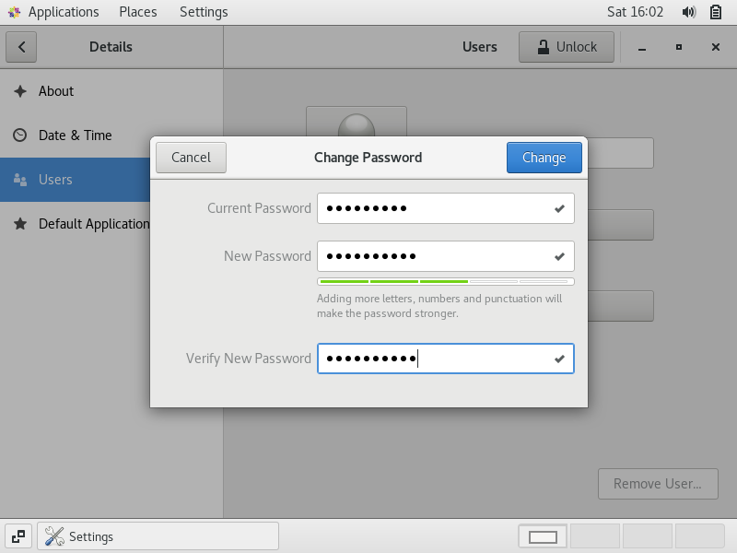
* The Password is not changed in this case as the length of the password is small   
  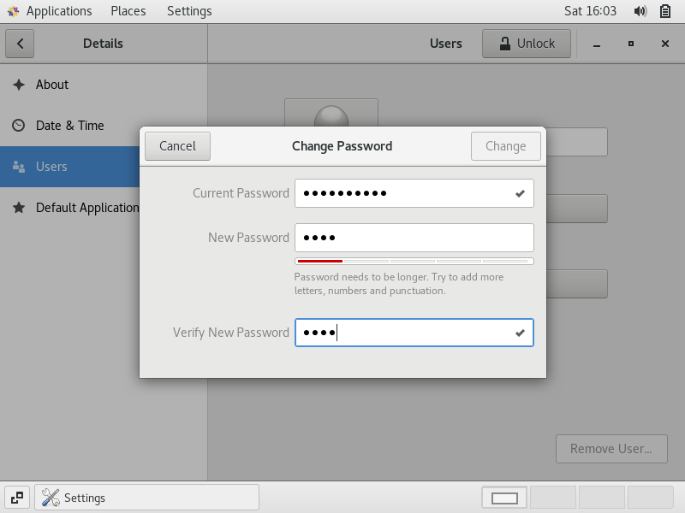
* The Password must be set, without it we cannot change  
    
  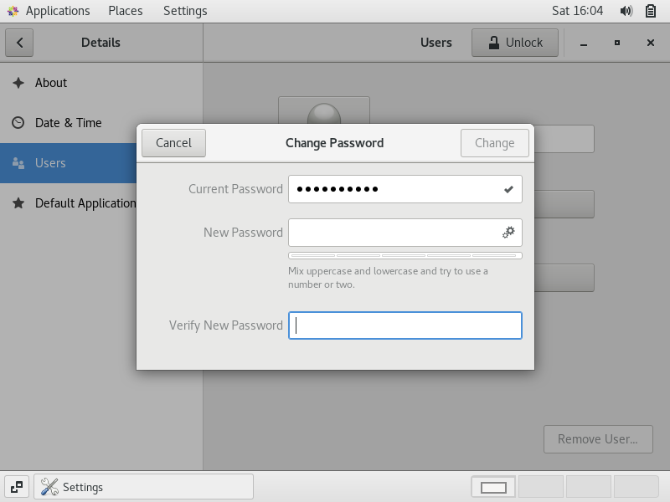

Assignment 3

* The directory is changed to home and it list all the folders in home directory 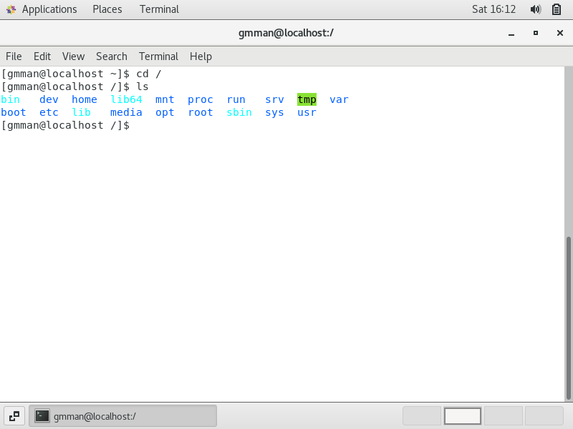
* The Directory is changed to home it contains user’s directory

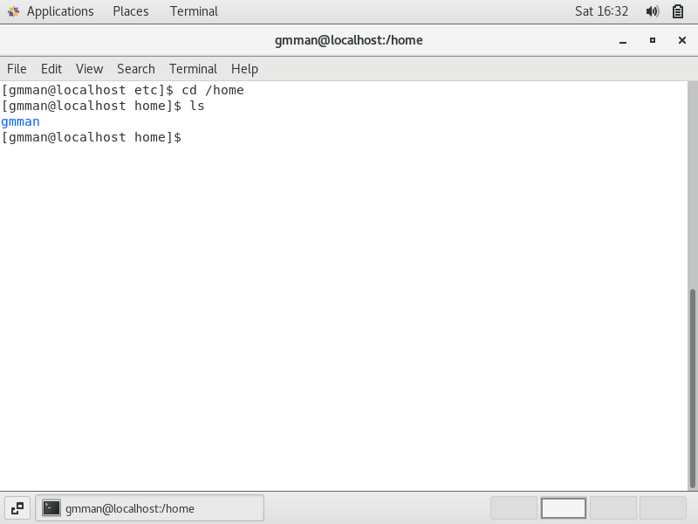

* This command makes to change directory to home directory

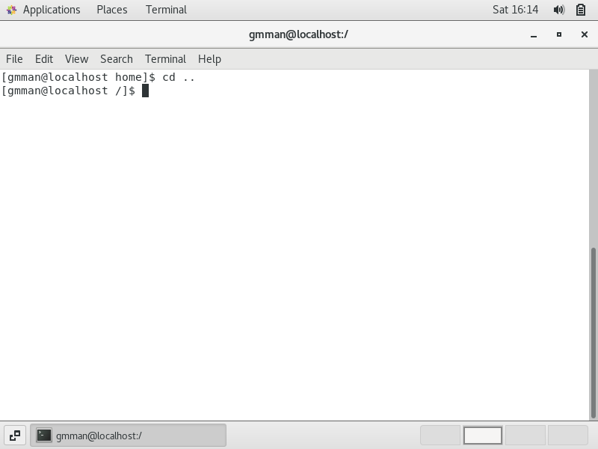

* There is no WWW directory available in var directory

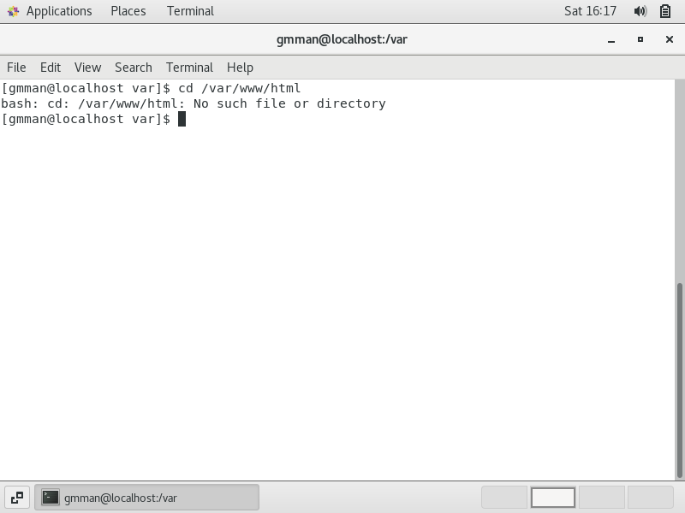

* Permission has been denied to enter root we need to use sudo command  
  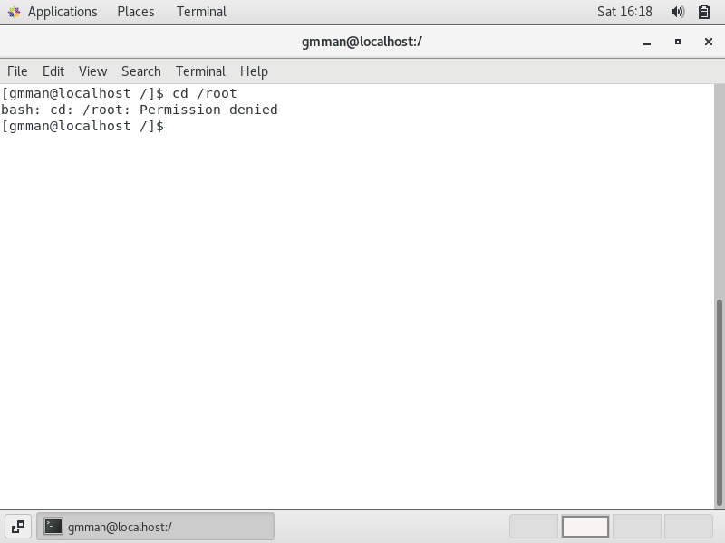

Assignment – 4

* First command changes directory to /etc and we cannot see the folders inside /etc to view the folder do a “ls” command

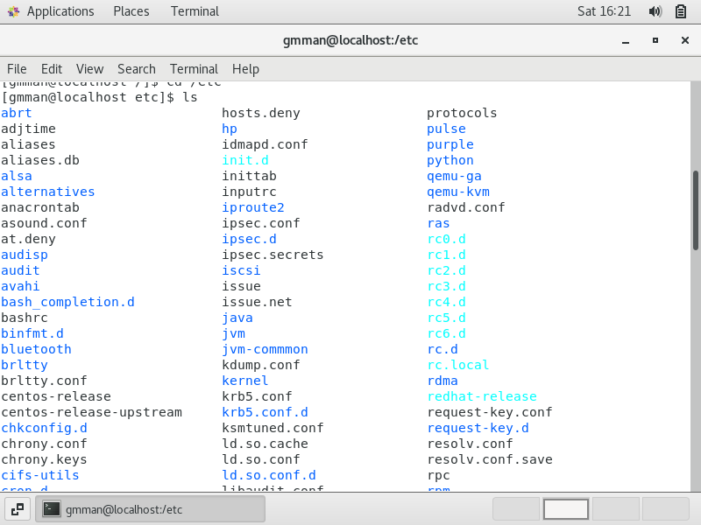

* It lists all the files in etc directory with details of the folder like the privileges, date and time etc

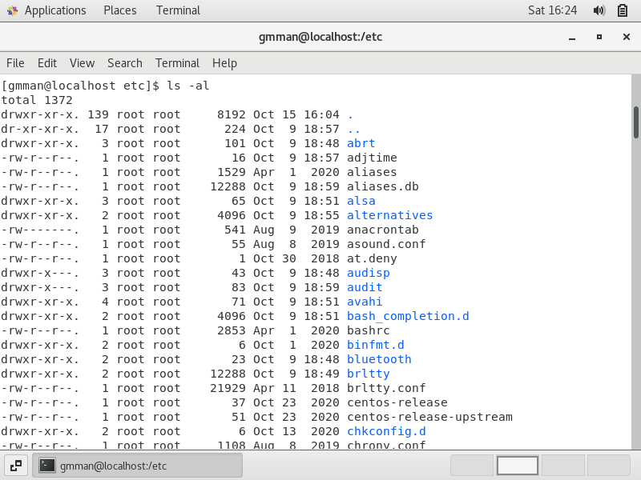

* This command list all the file along with index number

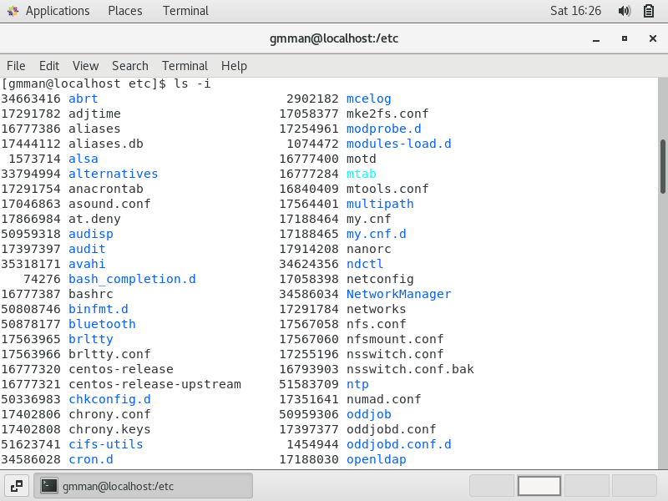

* This command helps to give information about the commands   
  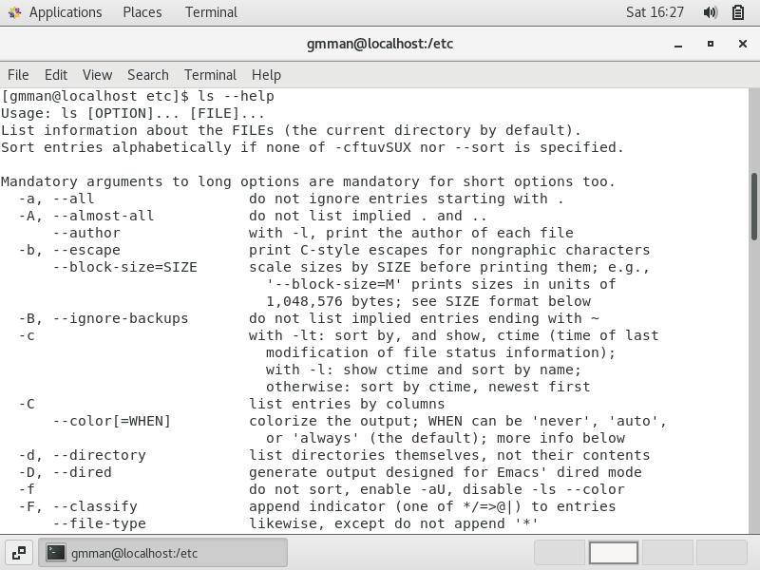

Assignment – 5

* In this command the terminal is in user directory   
  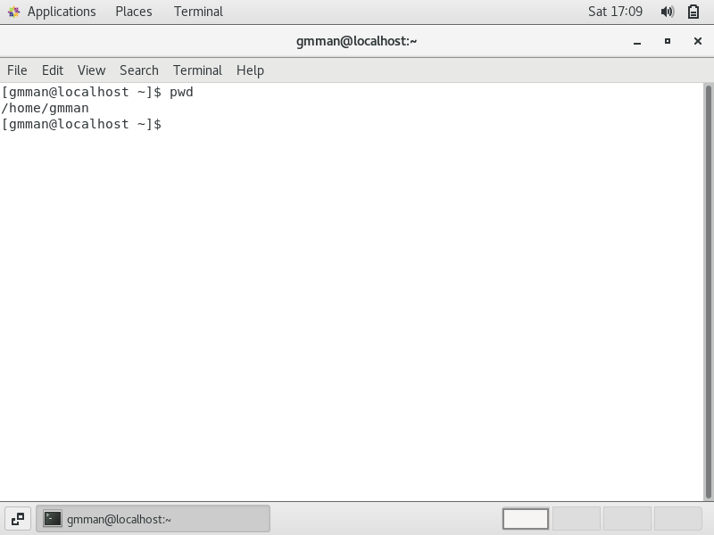
* In this we have changed the directory to /var folder and listed all the files available in it.  
  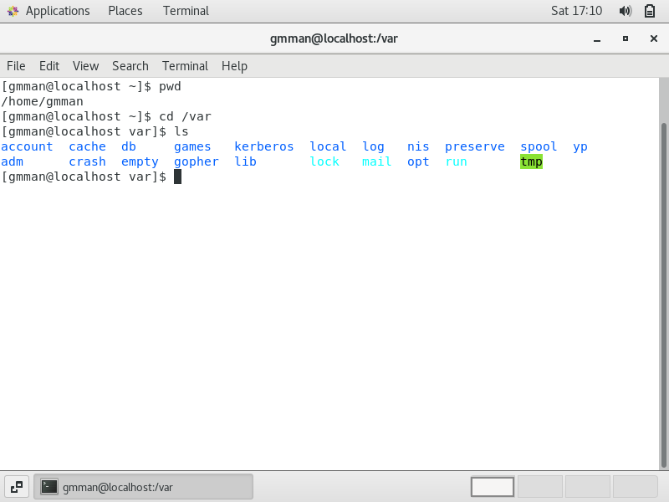
* Now in this command I have changed my directory to account and listed files available in the account directory.  
  